Zkhenna

Home About ZKhenna Body design Products Contact

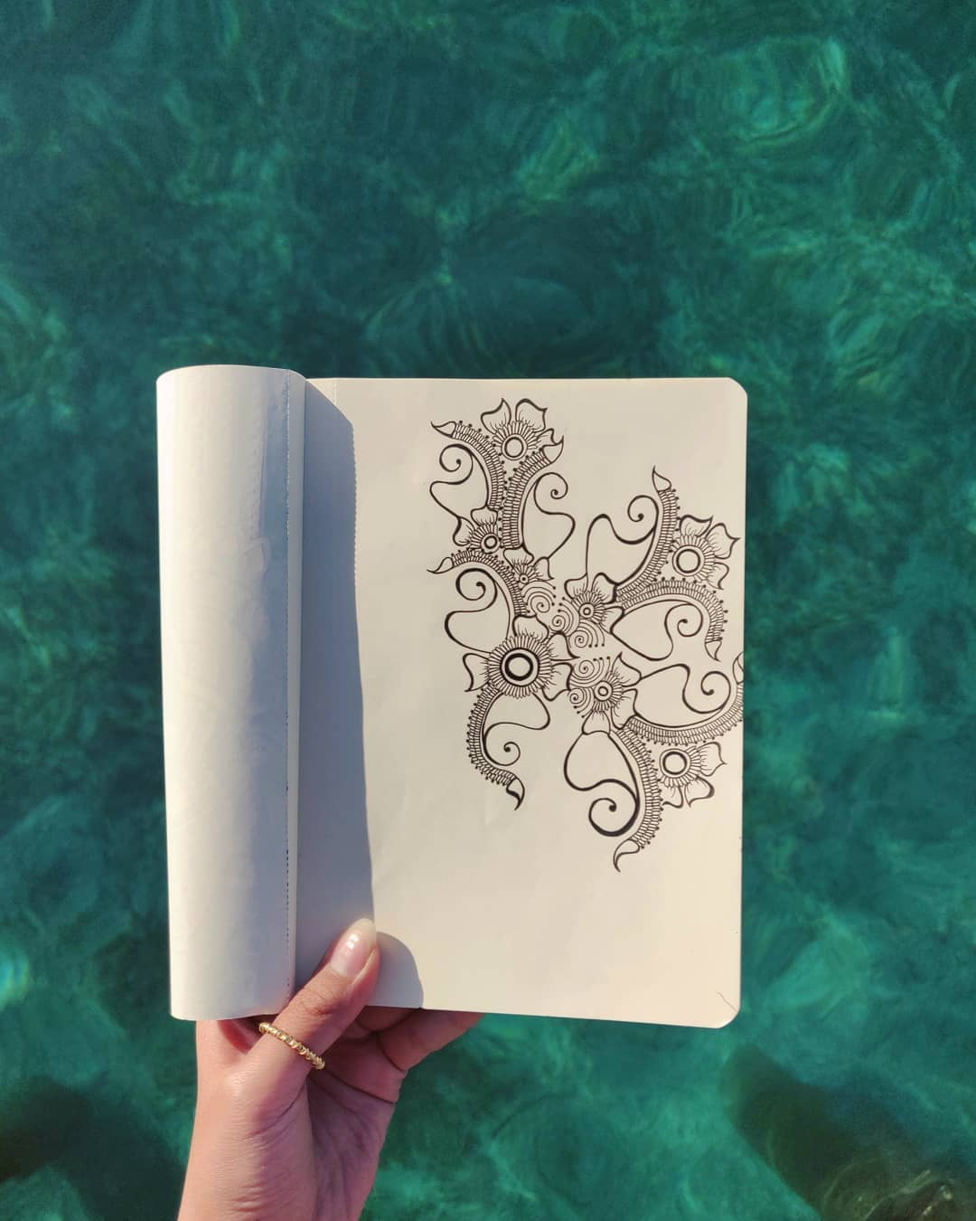

Featured Services

Instagram/Facebook/Email

Get on our list!....

